Linux – Terminal PacMan Package Installer
Dan Richter
08 Sep 2020

So, I wouldn’t be complete in my writings, if I didn’t give a brief introduction to using pacman in Manjaro/Arch based Linux distributions. :)

If you are running a Debian based Linux distro, such as Ubuntu or Mint, these commands will not work for you. See my previous writing on how to use the APT installer.

Also, if you are changing from a Debian based system running APT, to an Arch based system running pacman, it will be a little confusing at first. I hope this will help the information make a little more sense for you. Pacman uses switches, after the ‘pacman’ command, just like ‘apt’ or ‘apt-get’, but they are not full words, such as ‘apt install’ or ‘apt search’. Instead they use switches such as -S or -R.

pacman -S <package1_name> <package2_name>

This command will synchronize with the repository database, and then look for the packages you want to install. Once it finds matches, it will give you the option of installing them onto your system.

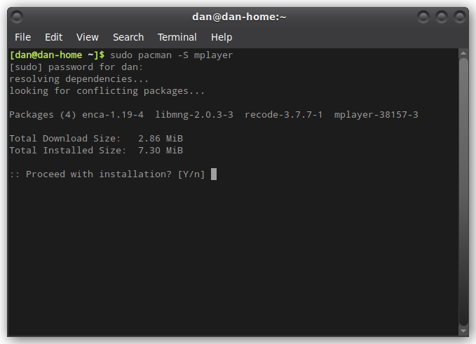
In this case, I did a search for mplayer. It is available to install, and if I hit <enter> or ‘Y’ at this prompt, it will go through the installation process and make the program available.
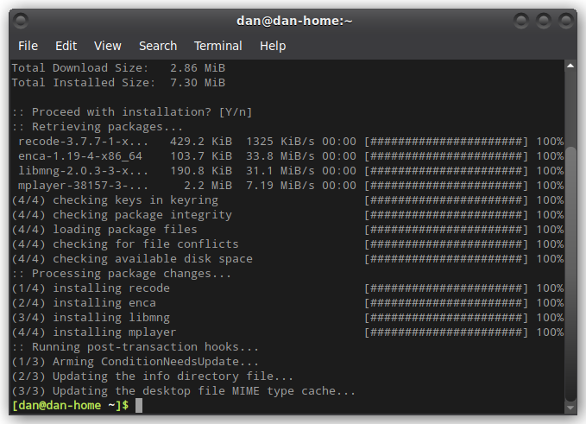
Once I hit <enter> this is the rest of the installation process.

pacman -R <package_name>

This command will remove a package from your system. Now that I have mplayer on my computer, let me show you how to remove it.

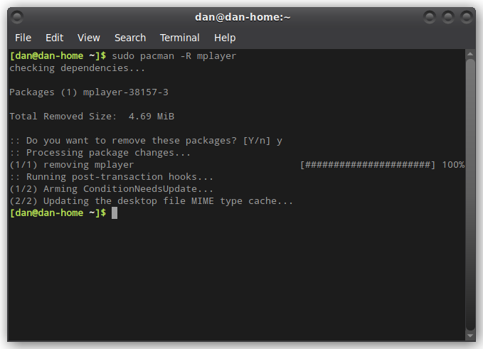
And just as quickly as it installed, it has been removed.

pacman -Rs <package_name>

When a program is installed on your computer, pacman will also install any dependencies that may be required at the same time. If you would like to remove those at the same time you remove the program, you can type in ‘sudo pacman -Rs mplayer’, or whatever program you are removing.

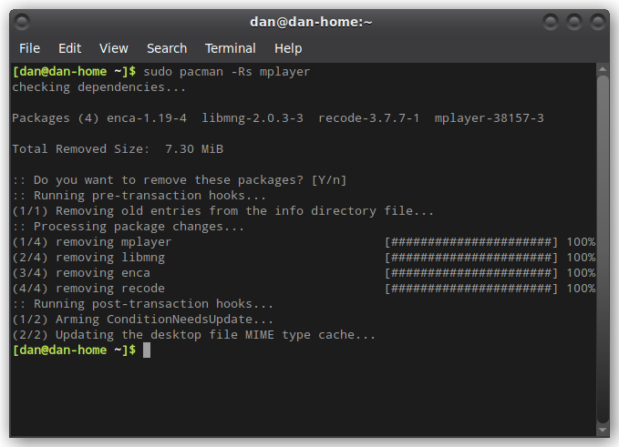
Did you notice a difference between the last two screen shots? The first one only removed mplayer, while the second one also removed 4 dependencies that were also installed.

pacman -Syu

Remember in the writing about Debians APT package management, I talked about doing the ‘apt update’ and ‘apt upgrade’ to do any upgrades available to your computer? Well, this is the pacman version of those two commands. If you type in ‘sudo pacman -Syu’, your system will actually perform three different functions.

S – Syncs with the repository
y – Refreshes the local database on your computer
u – Updates your system

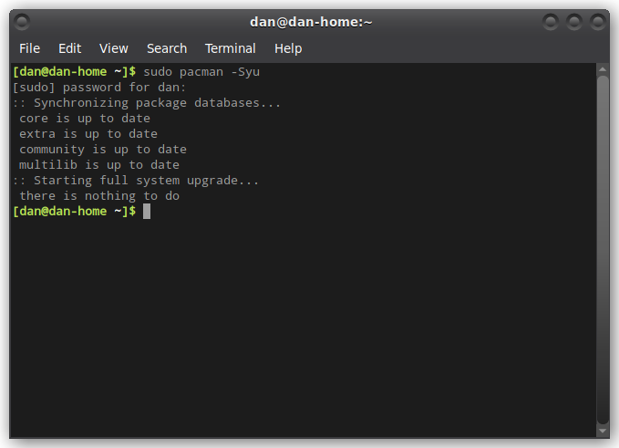
When I try the command on my system right now, this is what I’m seeing. I did have some upgrades yesterday that have already been completed. If there were upgrades available, it would give you an option to install them.

That is the very basics of using pacman on an Arch based distro. There are a lot more switches and combinations available to use, but we’ll get into those at a later date. For now, this is enough to keep your system up to date, and allow you to install fun programs like I talked about in the ‘terminal fun commands’ writing.

